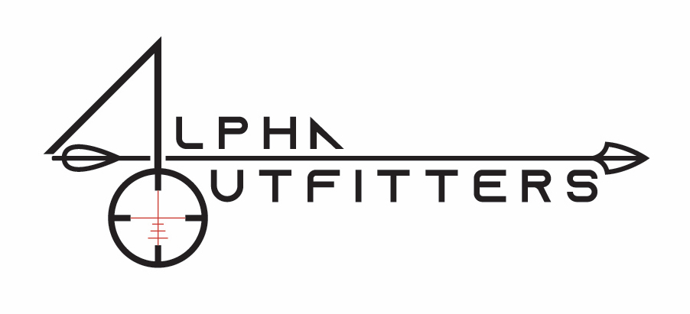

C.A.’S ALPHA OUTFITTERS, LLC
Release and Assumption of Risk

I hereby expressly assume any and all risks associated with hunting, shooting and fishing at any properties associated with C.A’s Alpha Outfitters, LLC. I know hunting, shooting and fishing are considered to be dangerous activities and I hereby assume the risk of any and all injuries I may suffer due to the grounds or physical condition of the any properties associated with C.A’s Alpha Outfitters, the acts of omissions of other hunters, shooters or fishermen who may be on or near C.A’s Alpha Outfitters whether with or without permission, equipment failures, acts of God, and/or for any other reason.

I understand that there will likely be other persons hunting, shooting, carrying firearms and fishing at any properties associated with C.A’s Alpha Outfitters. I agree to act prudently and carefully to avoid causing them any injury. I certify that I am familiar with the use and operation of the firearm(s) I will be using while at C.A’s Alpha Outfitters and that I am familiar with the rules of hunting, shooting and firearm safety.

I release C.A’s Alpha Outfitters together with all the members, employees, agents and representatives including without limitation, Christopher Alberts, for any and all personal injury and property damage which may arise in my favor and which may occur during, or as a result of, my presence at C.A’s Alpha Outfitters as reference above, regardless of the cause of any such injury and including those which may be caused by negligence and/or any other cause.

I give this release and assume all risks attendant thereto in considered of being allowed to enter into and hunt, shoot and fish at C.A’s Alpha Outfitters.

This release and assuming of risk will be binding on my heirs, executors and assigns.

I have read the above document and understand the contents.

Name (please print) Signature Date

Address City State Zip Code

For Parents/Guardians of Guests Under the Age of 18
This is to certify that I, as the parent/guardian with legal responsibility for this minor, do consent and agree to his/her release as provided above of all the Releasees, and for myself, my heirs, assigns and next of kin. I release and agree to indemnify and hold harmless the releasees, from any and all incidents to my minor child’s involvement or participation in any event as provided above, even if arising from the negligence of the Releasees, to the fullest extent permitted by law.

Parent/Guardian Signature Date Emergency Phone

